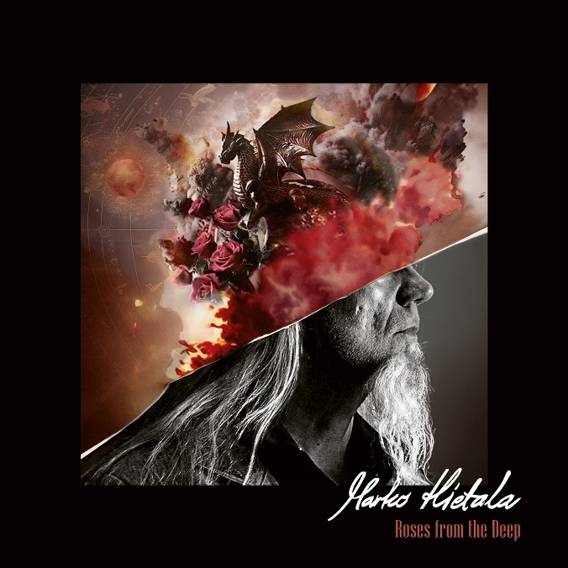

**MARKO HIETALA**

**»Roses From The Deep«**

##### OUT: February 7th 2025

|  |  |
| --- | --- |
| **Line up:** | **Marko Hietala online:** |
| Marko Hietala – vocals, bass  Tuomas Wäinölä - guitars  Vili Ollila – keyboards  Anssi Nykänen – drums | [https://www.facebook.com/markohietalaofficial](https://nuclearblast.us19.list-manage.com/track/click?u=f52be22febdeb73950b267672&id=5eb3d46cf3&e=d9ec70e513)  <https://www.instagram.com/markohietalaofficial> |

If you've followed the global shenanigans of heavier music over the past decades, you know the name **Marko Hietala**. And if you don't, I strongly suggest you go back down the dark rabbit hole and do your homework again.

There is no doubt about it: **Marko Hietala** has been synonymous with quality for more than four decades. **Hietala** has not only shaped, but also defined the sound of harder rock, as a founding member of the heavy metal band **Tarot**, as an essential member of the supergroup **Sinergy** (next to extreme talents such as Alexi Laiho) or as one of the key figures of world's biggest symphonic metal band **Nightwish**. Needless to say, his thunderous bass lines and rich vocals have been echoed in the world's most famous venues, such as Wembley Arena and legendary festivals like Rock in Rio. However, despite all the achievements, new conquests are coming at a steady pace... Just recently, **Marko Hietala** has appeared in a starring role in the Finnish TV series “Vain elämää”, which has gathered millions of viewers in Finland.

When it comes to an endlessly talented artist with a strong musical flame in his heart, an eponymous album is always just a matter of time. In the case of **Marko Hietala**, it took a while, but better late than never: his long-awaited first solo debut, ***Mustan sydämen rovio***, finally arrived to grace the spring of 2019 (later reissued in English as ***Pyre of the Black Heart*)**.

"Sometime in 2017-18, Nightwish took a break – first for about 20 years – and I decided to spend my time working on my first solo album", **Hietala** recalls.

"I've come up with all kinds of ideas over the years, and it was time to get them out of my system. When I set my sight on the album, I didn't limit myself in any way. If the idea felt good, it was good..."

Guess what? **Marko Hietala**'s musical and lyrical tide has not dried up and the well-received debut is getting the company it deserves. Released in February 2025, ***Roses from the Deep*** follows the adventurous path of its predecessor, but perhaps with even greater ambition. "There were no limits this time either", says **Hietala**. "Me and my bandmates could do simply anything!"

When the upcoming album was composed and immortalized, **Hietala**'s expressive band still included guitarist **Tuomas Wäinölä**, keyboardist **Vili Ollila** and drummer **Anssi Nykänen**. However, after the completion of the album, **Ollila** left the group and was replaced by **Bob Engstrand** (Turisas, Von Hertzen Brothers).

"Let's put it like this: ***Roses from the Deep***might exist without my bandmates, but it would be completely different – and much less adventurous", states **Hietala**. **Tuomas Wäinölä**, who also produced the album, also emphasizes the importance of the collective effort. "Marko comes up with the first spark of an idea, but the final songs are always the result of intense collaboration", he explains.

"When we worked on the first record a few years ago, our fruitful liaison was successfully started. However, with the second album, everything - the overall ambition, the song arrangements and so on - was taken to a new level."

The sheer power of ***Pyre of the Black Heart***should not be underestimated, but the new album feels like it has a little more of... well, everything compared to its predecessor. "One of the greatest examples would be the song *Dragon Must Die.* It perfectly showcases the album's versatility, shifting from downtuned metal to symphonic atmospheres, progressive polyrhythms and melodic Irish influences", **Hietala** states.

"I wrote the verse and the chorus first, but then Tuomas and Vili took over... pretty much completely. And what happened? The verse and the chorus are still there, but then there's a lot more. I mean a lot! When **‘Dragon Must Die’** was finished, I was totally blown away, and it certainly wasn't the only time during this album process..."

This is where **Hietala** comes to the heart of the new album. Cliché or not, but ***Roses from the Deep*** is all killer, no filler record. Whether it's the touching atmosphere of **‘*Two Soldiers’*** (featuring deep-voiced **J-P Leppäluoto** on vocals), **‘Tammikuu’** bursting with raw energy (yes, sung in Finnish), the monumentally ambitious and melodically rich title track or the single/video tune **‘Frankenstein's Wife’**, the second **Marko Hietala** album sends serious shivers down the listener's spine.

 And then there's **‘Left on Mars’.** "Of course, **‘Left on Mars’** is one of the album's key tracks. When I got the original idea, I didn't think that this could become a fascinating duet, but Tuomas started throwing the idea on the table... And what happened? Ex-Nightwish singer **Tarja Turunen** - we have toured with her band recently and will continue to tour in 2025 - immediately jumped in as my duet partner. I can't even describe how heartfelt this feels to me!"

Lyrically, ***Roses from the Deep*** is just as multifaceted as its music. "Some songs are deeply personal, reflecting my own struggles with frustration and depression. Others are more socially aware, looking critically at political ideologies, organizations, fearmongers and so on. There's also some fantasy elements and imaginative storytelling there", describes **Hietala**.

One of the distinguishing features of ***Roses from the Deep*** is its rich soundscape. Its secret? One could be that the **Marko Hietala** band recorded the songs live in the studio and the band's groove was not killed by moving everything to the grid. There are also no digital drum samples, but instead there is a real piano, analog synths, Hammond organ and even a full string orchestra. This band proudly "works like a dinosaur".

"We wanted to capture the energy of the musicians and the individuality of the playing," says **Wäinölä**. "There were no shortcuts. When an instrument is played by a real human being, it has a certain energy. And you can hear it – these songs have life." Some might say that the album's sound is reminiscent of old rock legends – Deep Purple, Black Sabbath, Alice Cooper – but it also has a fresh and contemporary edge.

"One thing is sure: the album – mixed by Finnish extraordinaire **Jesse Vainio** – breathes freely and there's an uplifting spirit all over the place", describes **Wäinölä.** "To my ears, ***Roses from the Deep***sounds like a timeless classic rock album", adds **Hietala**.

Well, one last thing then... What is the song **‘Proud Whore’** all about? "More than other tracks, it has a bit of a '90s vibe. Maybe somewhere between Soundgarden and Alice in Chains", smiles **Wäinölä**. **Hietala** laughs and adds: "Don't be offended by the title... It's a song about us! We practice the world's oldest profession: we are entertainers. Well, here we come again and entertain you for one album!"